
This Mum Moves (TMM) Ambassador Training is a half-day training event that will equip professionals with the knowledge, skills, and confidence to discuss physical activity during pregnancy and after childbirth.

This Mum Moves Ambassador Training Application
The training is delivered live via Zoom and will provide learners with access to a digital toolkit to support conversations and further learning. It will also provide participants with the resources to facilitate the promotion of physical activity, including cascade and promotional materials. This training has been accredited by the CPD Standards Office and equates to 3 CPD points.

What is This Mum Moves?
TMM is an educational programme which aims to empower women to make informed physical activity choices throughout pregnancy and beyond by providing professionals with the tools to discuss physical activity during the childbearing years. The programme has been co-produced by women and professionals, piloted in five areas of England, and evaluated independently over the last three years. Since 2022, the programme has been delivered in partnership by the Active Pregnancy Foundation (APF) and Institute of Health Visiting (iHV).

What will I learn on this training?
This training is aimed at professionals who work with and have regular contact with women during their childbearing years. The learning objectives are:
- To be familiar with the evidence base for physical activity during and beyond pregnancy, including national guidelines and activity level definitions;
- To effectively promote physical activity using the Chief Medical Officers’ (CMO) physical activity guidance;
- To provide appropriate and timely advice, guidance and signposting to trusted resources;
- To be able to access resources to support physical activity conversations and engagement; and
- To understand the role of a TMM Ambassador in raising awareness and increasing physical activity engagement as part of a healthy lifestyle.

Next Training Date:
Tuesday 23rd June 2026 – 9:00-1:00pm ☐
Thursday 24th September 2026- 9:00-1:00pm ☐

Cost: £180.00 (no VAT)


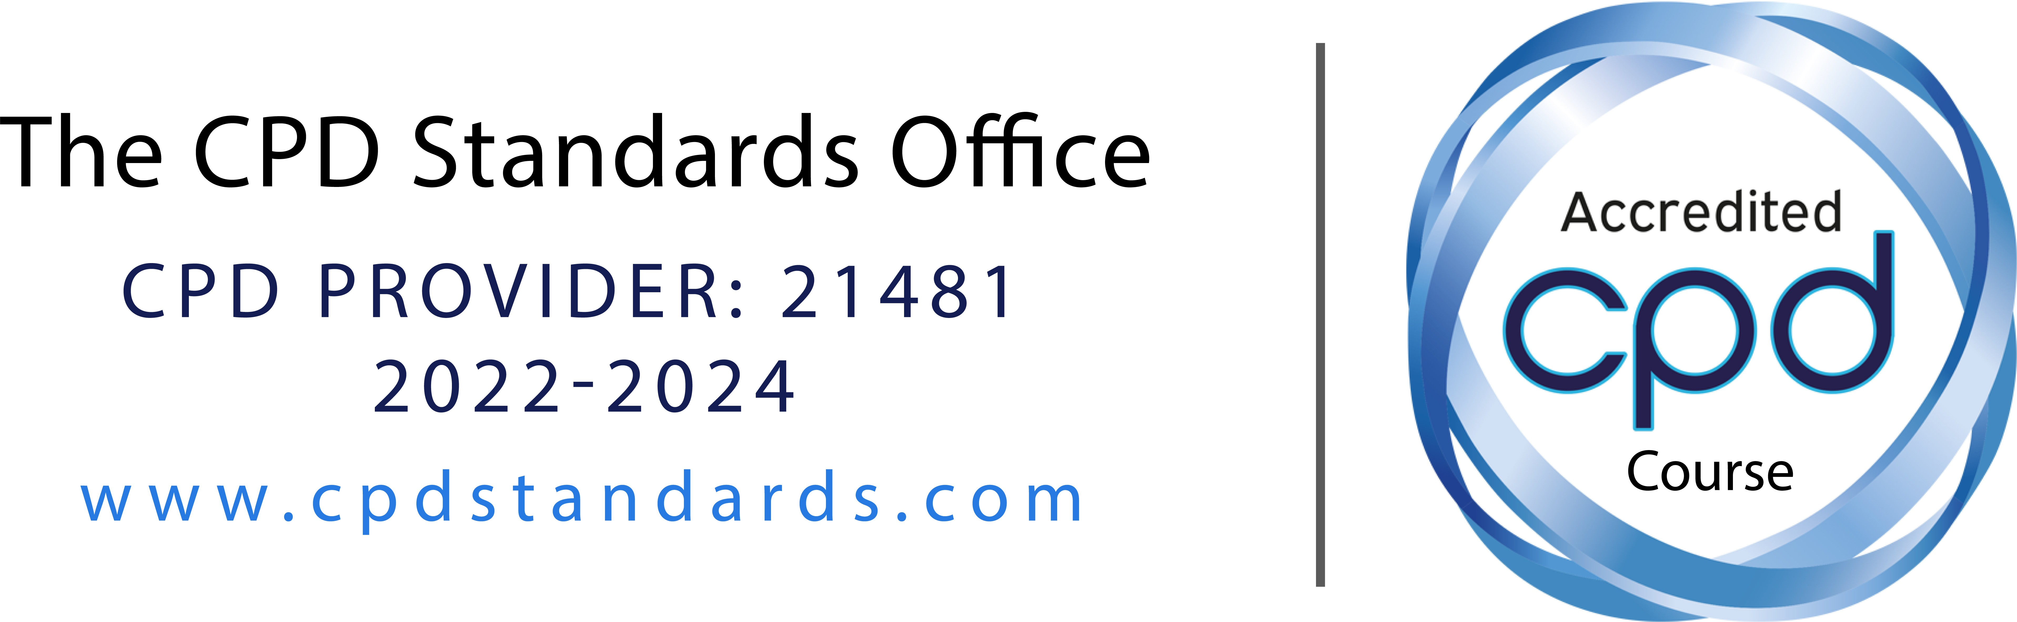

Applying for a training place:
To apply for a training place, please fill in the section below and send completed forms to training@ihv.org.uk. Please also see the Terms and Conditions outlined below.

Event date
Name
Job title
Organisation
Email
Work address
Mobile phone no.
Confirm you have the  following to support your attendance: | Laptop or PC with a camera/microphone  A quiet place to join from (not a busy office)
Tell us how you intend
to benefit from the training you are attending (ie. how will you use your Ambassador status?):
Funding information | Please identify a preferred payment method: BACS bank transfer  Card payment  Invoice  If the payment information will be sent from a third party, please insert their email contact details here:

TERMS AND CONDITIONS
By submitting the booking and registration form, you agree to the booking terms and conditions. This includes consenting to iHV and APF storing your personal details (name, work role, email address and date of training attended).

BOOKING:
- Reservations are accepted on a first-come-first-served basis on receipt of a completed application form and confirmation of funding.
- If we are unable to accommodate you at your chosen event, you will be offered an alternative date for the next scheduled event.

- We reserve the right to review the applications received and to rescind/refuse access to training to individuals requesting places, or to request further information.
- Your place is considered confirmed by us as soon as the invoice for your place has been issued by us.
- Once your place is confirmed, you may become liable for cancellation fees as detailed below.

CANCELLATION:
- Cancellations will be accepted in writing BY EMAIL ONLY. Verbal cancellations will not be accepted at any time. Should you need to cancel, please send your request to: training@ihv.org.uk.
- Cancellations received on/or prior to 5pm, 28 days before the training event, will be refunded in full subject to a £25 administration fee. Any outstanding invoices awaiting payment at the time of cancellation are subject to the same terms and conditions.
- Cancellations received after less than 28 days prior to training will be subject to the following scale of fees: 50% of cost of place refunded if cancelled less than 4 weeks prior to the event; 25% of the cost of place refunded if cancelled less than 2 weeks prior to the event; no refund if cancelled 7 days or less before training event.
- In the unlikely event that the training is cancelled by us due to unforeseen circumstances, the cost of the training place will be refunded in full (via the original payment method).

USE OF RESOURCES:
We apply the following conditions to the use of the resources provided to TMM Ambassadors following training:

- Access to the This Mum Moves resources is granted for 2 years following training, after which a renewal fee or refresher may be applicable for continued access.
- All This Mum Moves branded resources provided remain the intellectual property of the This Mum Moves programme and are subject to copyright.
- No part of the materials provided should be used by the professional who attended the training (or anyone else) for any commercial gain.
- The resources are provided only for use by the Ambassador who attended training. Never share your login details with others. The resources provided may be disseminated by the Ambassador for raising awareness with colleagues and consolidating their learning.
- This Mum Moves Physical Activity Awareness Sessions (i.e.cascade) can only be delivered within an Ambassador’s organisation, to colleagues in their local network or sphere of practice and not be hosted or advertised to the public or external organisations.
- The wording or content of the PowerPoint slide sets provided should not be amended by the Ambassador without the permission of This Mum Moves. Please advise us if you detect any issues and we will make appropriate amendments.
- Each slide set should be used in line with the associated lesson plans provided. This is for quality assurance purposes as the programmes provided have been benchmarked against national frameworks and standards.
- The content of the resources will be updated periodically. To remain up-to-date, Ambassadors should ensure they are using the latest versions of resource materials.
- The This Mum Moves partnership will not be liable for the quality of subsequent cascade sessions delivered by its Ambassadors.

DATA PROTECTION AND PRIVACY:
Information provided by applicants to and participants on our training programmes is carefully stored and we work to Data Protection regulations (GDPR) 2018. For more information on how we protect your privacy please see our Privacy Policy at: https://ihv.org.uk/privacy-and-cookies/ and https://www.activepregnancyfoundation.org/gdpr- privacy-policy

